JSON Configuration File

What is a JSON Configuration File?
# Source: AI Source: Provided by: [Data Path: Persons Table -> ID Column: 1, Name_En Column: Motasem Essam] -> From: [Chatgpt (GPT‑5 Mini)] on [1/26/2026]
A JSON Configuration File is a file written in JSON (JavaScript Object Notation) format that stores configuration settings for an application.
- It allows an app to read structured data to configure its behavior.
- Unlike .env files (simple key-value pairs), JSON supports nested structures, arrays, and objects.
- Typically used in web apps, Node.js projects, and modern software.

Key Characteristics
# Source: AI Source: Provided by: [Data Path: Persons Table -> ID Column: 1, Name_En Column: Motasem Essam] -> From: [Chatgpt (GPT‑5 Mini)] on [1/26/2026]
- Format:
  - Text-based, structured as key-value pairs
  - Supports nested objects and arrays
  - Keys are strings in double quotes
  - Values can be: strings, numbers, booleans, arrays, or objects
- File Extension: .json
- Purpose:
  - Store app settings, feature toggles, API endpoints, themes, etc.
  - Keep config separate from code
  - Easy to parse programmatically

Example JSON Configuration File
# Source: AI Source: Provided by: [Data Path: Persons Table -> ID Column: 1, Name_En Column: Motasem Essam] -> From: [Chatgpt (GPT‑5 Mini)] on [1/26/2026]
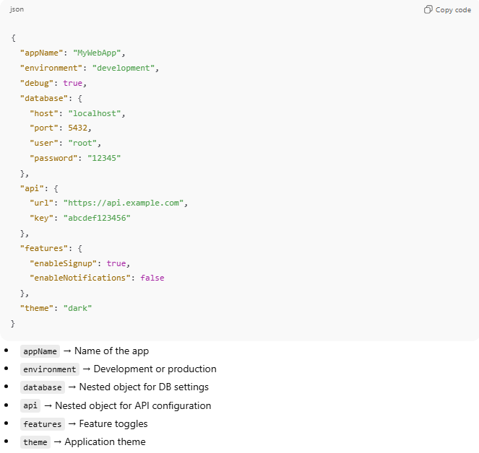
config.json
{
"appName": "MyWebApp",
"environment": "development",
"debug": true,
"database": {
"host": "localhost",
"port": 5432,
"user": "root",
"password": "12345"
},
"api": {
"url": "https://api.example.com",
"key": "abcdef123456"
},
"features": {
"enableSignup": true,
"enableNotifications": false
},
"theme": "dark"
}
- appName → Name of the app
- environment → Development or production
- database → Nested object for DB settings
- api → Nested object for API configuration
- features → Feature toggles
- theme → Application theme

How to Use in Code
# Source: AI Source: Provided by: [Data Path: Persons Table -> ID Column: 1, Name_En Column: Motasem Essam] -> From: [Chatgpt (GPT‑5 Mini)] on [1/26/2026]
Node.js Example
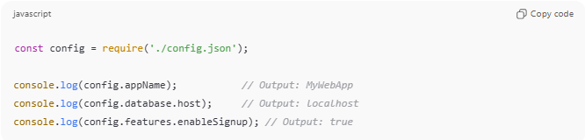
const config = require('./config.json');

console.log(config.appName); // Output: MyWebApp
console.log(config.database.host); // Output: localhost
console.log(config.features.enableSignup); // Output: true
Python Example
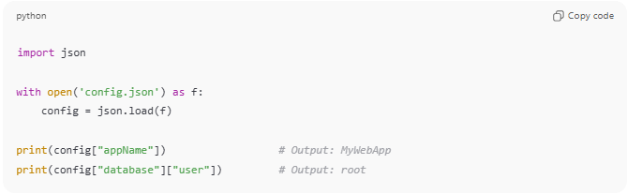
import json

with open('config.json') as f:
config = json.load(f)

print(config["appName"]) # Output: MyWebApp
print(config["database"]["user"]) # Output: root

Advantages
# Source: AI Source: Provided by: [Data Path: Persons Table -> ID Column: 1, Name_En Column: Motasem Essam] -> From: [Chatgpt (GPT‑5 Mini)] on [1/26/2026]
- ✅ Structured and readable
- ✅ Supports nesting (easy for complex configurations)
- ✅ Language-independent and widely supported
- ✅ Easy to validate (with JSON schema)

Disadvantages
# Source: AI Source: Provided by: [Data Path: Persons Table -> ID Column: 1, Name_En Column: Motasem Essam] -> From: [Chatgpt (GPT‑5 Mini)] on [1/26/2026]
- ❌ Cannot store comments (JSON doesn’t allow comments)
- ❌ Slightly more verbose than .env for simple key-value settings

💡 Analogy:
# Source: AI Source: Provided by: [Data Path: Persons Table -> ID Column: 1, Name_En Column: Motasem Essam] -> From: [Chatgpt (GPT‑5 Mini)] on [1/26/2026]
A JSON config file is like a blueprint for your app. It tells the app exactly how to behave, what services to use, and which features to enable, all in a structured, machine-readable way.

